FUZZY LOGIC OPTIMIZATION OF MOISTURE CONTENT IN BOILER WOOD FUEL OF A TEA PROCESSING FACTORY IN KENYA.

Kamunge Moses¹, Peter Okemwa², Isaack Nangendo³.
¹ University of Eldoret Department of technology education, ² University of Eldoret Department of technology education, ³ University of Eldoret Department of technology education,

Abstract
This research investigates the use of fuzzy logic to optimize the moisture content in wood fuel used for boiler in Kenya's tea processing factory. Moisture levels are crucial as they influence combustion efficiency, energy production, and emissions levels. By integrating a fuzzy logic control system into the wood-fired boiler, the moisture content was significantly reduced from an initial 23% to a more optimal 18%, as determined by simulation outcomes. This 5% reduction in moisture content was accomplished through the dynamic adjustment of various boiler operating parameters, including fuel feed rate, combustion air flow, and steam pressure, utilizing a fuzzy logic algorithm that drew on both expert insights and real-time sensory data. The simulated operation of the fuzzy logic control system showed an enhancement in boiler efficiency to 81%, a decrease in emissions to 178g/kWh, and an overall improvement in system reliability, thereby demonstrating the efficacy of fuzzy logic for enhancing wood-fired boiler performance and addressing moisture-related challenges.

Keywords
Fuzzy Logic, Moisture Content, Wood Fuel, Boilers, Efficiency.

1.0 Introduction
The tea processing industry is a vital component of Kenya's economy, contributing significantly to export revenues and employment opportunities. Boilers powered by wood fuel are commonly used for energy generation in tea processing but are often plagued by inefficiencies stemming from variable moisture content in the fuel (Ogot et al., 2020). Excessive moisture in wood fuel can lead to lower combustion efficiency, increased emissions, and reduced energy output. This paper investigates the potential of fuzzy logic systems to optimize the moisture content in wood fuel, enhancing boiler performance in the Kenyan tea processing sector.

2.0 Literature Review

2.1 Tea Processing in Kenya
Tea processing is a crucial step in the tea production chain that significantly impacts the quality, marketability, and profitability of tea in Kenya. As one of the leading tea producers globally, Kenya’s economy relies heavily on this sector. The processing of tea involves several stages, including withering, rolling, fermentation, drying, and sorting, which determine the final product's characteristics and quality.
The tea sector is a vital contributor to Kenya's economy, providing employment and supporting livelihoods for millions of people. It is one of the country’s leading foreign exchange earners. Approximately 30% of all agricultural exports are tea, and processing plays a key role in enhancing its value (Karachi & Suri, 2021).
Processing techniques directly affect the flavor, aroma, and health benefits of tea. Properly processed tea yields higher quality products that can fetch premium prices in international markets. Innovations in processing technologies, such as mechanization and automated quality control systems, have enabled Kenyan tea processors to meet global standards (Ng’ang’a et al., 2022).
Tea processing not only improves quality but also facilitates value addition. As consumer preferences shift towards specialty teas, processing methods that enhance the distinctive qualities of Kenyan teas are increasingly important. This diversification and specialization are crucial for maintaining competitiveness in the global tea market (Kamau et al., 2023).
Sustainable processing practices are gaining attention as global consumers become more environmentally conscious. There is a growing emphasis on eco-friendly processing methods that minimize waste and reduce environmental footprints (Mutuku & Karanja, 2023). Implementing sustainable practices in tea processing helps conserve resources and enhances the appeal of Kenyan tea to environmentally conscious consumers.

2.2 The Significance of Fuel Quality in Boilers
Wood fuel is often the primary energy source for many tea factories. However, variability in the moisture content of this fuel can adversely affect boiler efficiency. Research by Gitari and Chege (2019) indicates that moisture levels exceeding 25% can lead to significant energy losses and increased operational costs.

2.3 Fuzzy Logic Applications in Energy Management
Fuzzy logic is a computational approach that mimics human reasoning, offering advantages in handling uncertainties inherent in complex industrial processes (Zadeh, 1994). Studies have shown that fuzzy logic systems can optimize various parameters in industrial boilers, including fuel moisture content (Aydin & Koç, 2020). This method provides a basis for creating adaptive control systems capable of maintaining optimal moisture levels leading to enhanced combustion performance.

2.4 Critical review on Optimization Techniques

Several studies have reported on optimization techniques for biomass boilers. For instance, Ahmad et al. (2021) utilized a fuzzy logic controller to regulate fuel feed rates based on moisture content, achieving a marked improvement in thermal efficiency. Similarly, Zhao et al. (2022) demonstrated how fuzzy algorithms can optimize biomass combustion processes by controlling various parameters based on real-time data. Additionally, Lee et al. (2023) explored the integration of machine learning algorithms in predicting optimal combustion conditions, resulting in increased efficiency and reduced emissions. Moreover, Tran et al. (2023) focused on the role of artificial intelligence in optimizing fuel quality assessment for biomass boilers, highlighting improvements in operational performance. Finally, Kumar and Raghav (2023) evaluated the impact of feedstock variability on biomass boiler efficiency, suggesting adaptive control strategies to enhance performance under different fuel conditions.

3.0 Methodology

3.1 System Design
The fuzzy logic control system proposed in this study includes several components aimed at regulating the moisture content in wood fuel before it enters the boiler. The system will use input variables such as initial moisture content, desired combustion temperatures, and ambient temperature.

3.2 Fuzzy Controller Structure
The fuzzy logic controller (FLC) will be designed with the following steps:
- Identification of input Variables: These include wood moisture content, operating temperature, and load demand.
- Determination of output Variables: The output will adjust the fuel feed rate and drying time.
- Development of fuzzy Rule Base: Based on expert knowledge, rules such as "IF moisture is high THEN increase drying time" will be defined.
- Defuzzification process: The center of gravity method will be used to convert the fuzzy output into a precise control signal.

3.3 Data Collection
Data will be collected from selected tea processing facilities in Kenya, focusing on real-time moisture readings and operational parameters over a specified period. The collected data will inform the development of the fuzzy logic system’s parameters.

3.4 Simulation Environment
The design and implementation of the fuzzy logic controller will be simulated using MATLAB/Simulink, allowing for visual feedback and data analysis of fuel efficiency and emissions. To develop fuzzy rules for improving the moisture content of wood fuel in a boiler following inputs and outputs variables were considered.

3.4.1 Input variables

Table 3.1 Data from wood fired boiler.
OBSERVATION | CURRENT MOISTURE CONTENT (CMC) (%) | DESIRED MOISTURE CONTENT (DMC) (%) | TEMPERATURE (T) (°C) | LOAD DEMAND (LD) (%)
1 | 20 | 15 | 90 | 75
2 | 18 | 15 | 85 | 80
3 | 22 | 15 | 95 | 70
4 | 21 | 15 | 92 | 60
5 | 19 | 15 | 88 | 85
6 | 17 | 15 | 91 | 65
7 | 15 | 15 | 89 | 90
8 | 16 | 15 | 94 | 55
9 | 23 | 15 | 97 | 50
10 | 24 | 15 | 96 | 40

3.4.2 Fuzzy Rule Base:
Based on expert knowledge and empirical data, the following fuzzy rule base can be developed:
Table 3.2 Expert based fuzzy rules
RULE ID | CONDITION | ACTION | FUZZY LOGIC REPRESENTATION
1 | CMC High | LD High | IF (CMC is High) AND (LD is High) THEN (DT is Short)
2 | CMC Medium | T High | IF (CMC is Medium) AND (T is High) THEN (DR is Medium)
3 | DMC Reached | CMC Close to DMC | IF (DMC is Reached) AND (CMC is Close to DMC) THEN (DT is Very Short)
4 | CMC Low | LD Low | IF (CMC is Low) AND (LD is Low) THEN (DT is Medium)
5 | CMC High | T Low | IF (CMC is High) AND (T is Low) THEN (DT is Longer)
6 | DMC Not Reached | CMC Above DMC | IF (DMC is Not Reached) AND (CMC is Above DMC) THEN (DT is Longer)

In this study, each rule in a fuzzy logic is assigned a unique identifier, known as the Rule ID, to facilitate easy reference and management. The condition section specifies the precise circumstances that must be met for the rule to be activated, essentially defining the trigger points for the rule's execution. Upon meeting these conditions, the rule executes a predetermined action, which represents the desired outcome or response. The fuzzy logic representation of the rule is mathematically expressed using the IF-THEN syntax, providing a structured format for representing and analyzing the rule's behavior.

The rules outlined above are designed to achieve several objectives. Firstly, they aim to reduce drying time in situations where both the current moisture content and load demand are high. Secondly, the rules seek to increase the drying rate when the current moisture content is at a medium level and the temperature is high. Thirdly, they indicate that drying should be stopped once the desired moisture content is achieved and the current moisture content is nearing this target. Additionally, the rules are intended to maintain a moderate drying time when the current moisture content and load demand are both low. Conversely, they suggest prolonging the drying time when the current moisture content is high and the temperature is low. Finally, the rules also call for an increase in drying time if the desired moisture content has not been reached and the current moisture content exceeds this level.

3.4.3 Membership Functions:
The membership functions define how the variables map to their respective fuzzy sets (High, Medium, Low, etc.).
Table 3.3
Variable | Membership Function | Range
CMC | Low | [0%, 10%]
CMC | Medium | [10%, 18%]
CMC | High | [18%, 25%]
GM | Low | [150,180]
GM | Medium | [190,200]
GM | High | [210-300]
LD | Low | [20%, 50%]
LD | Medium | [50%, 80%]
LD | High | [80%, 100%]
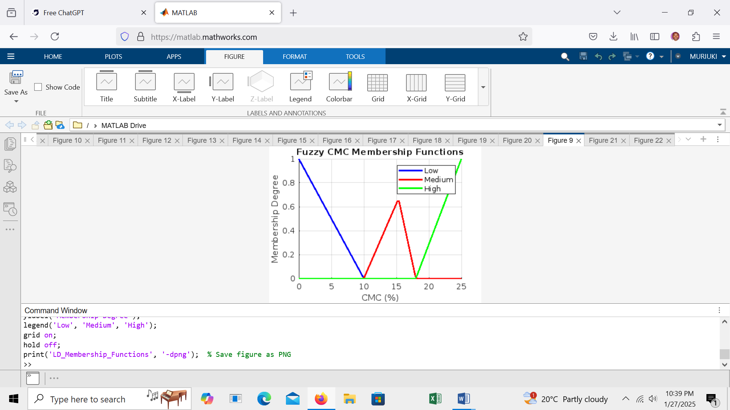
Figure 3.1 Membership functions for GM, LD and CMC

The membership functions for the outputs (DR) map the input values to their respective fuzzy sets.

3.4.5 Defuzzification:
Using the Center Of Gravity method, the defuzzified outputs can be calculated as follows:
The mathematical representation for the fuzzy outputs (Drying Rate DR) can be expressed as follows:
Drying Rate=k⋅A⋅ (T−T_{o}) ⋅ (M_{o}​−M_{t}​)
Where:
- k = drying constant (specific to the material and conditions)
- A = surface area of the wood (m²)
- T = temperature of the drying air (°C)
- T_{o}​ = initial temperature of the wood (°C)
- M_{o}​ = initial moisture content (kg)
- M_{t}= current moisture content (kg)
However, based on the available data k =0.729 kg/m, A=2m² , T=100ºc ,T_{o} =25 ºC ,M=150 kg and M_{o} =50 kg .The calculated drying constant was determined to be 0.729 kg/m, leading to a predicted drying rate of 0.73kg/min under the specific conditions of the experiment. The result of the drying rate in this study was applied as a membership function in the developed fuzzy logic.

4.0 Results and Discussion

4.1 Simulation Results

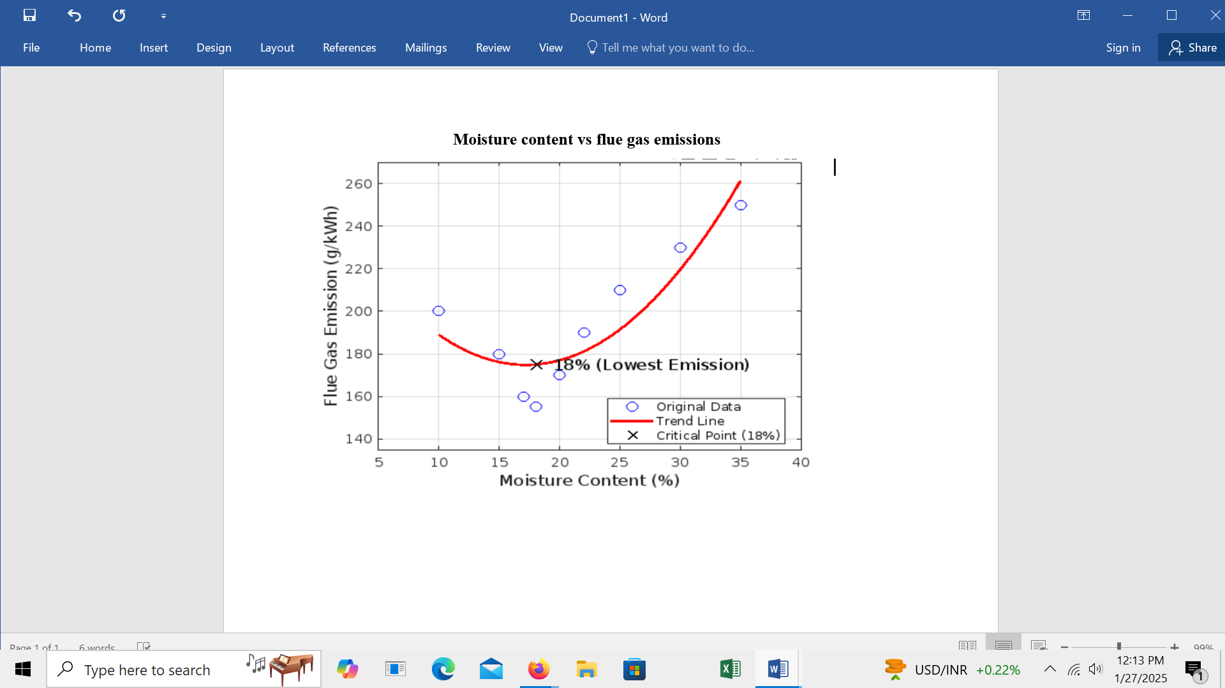

Figure 3.2 Graph for moisture vs flue gas

At 18% moisture content, the emissions level of 178 g/kWh indicates an acceptable combustion performance, balancing energy output and emissions release. This is typically an optimal moisture range for combustion; going above this might increase emissions due to incomplete combustion, while going much below could lead to dry fuel burning too quickly, potentially producing more nitrogen oxides (NOx) or other harmful emissions

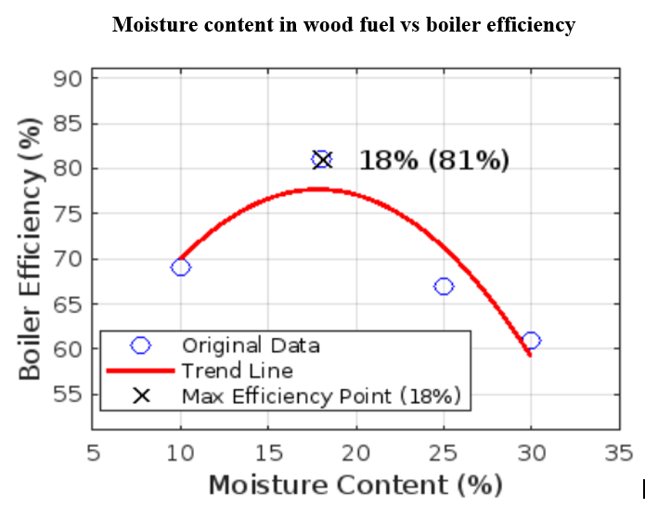

Figure 3.3 Graph for moisture vs boiler efficiency

The graph indicates that at a moisture content of 18%, the boiler achieves its peak efficiency of 81%. This is an important operational characteristic, as it highlights the optimal moisture level for maximizing energy output from the boiler system.

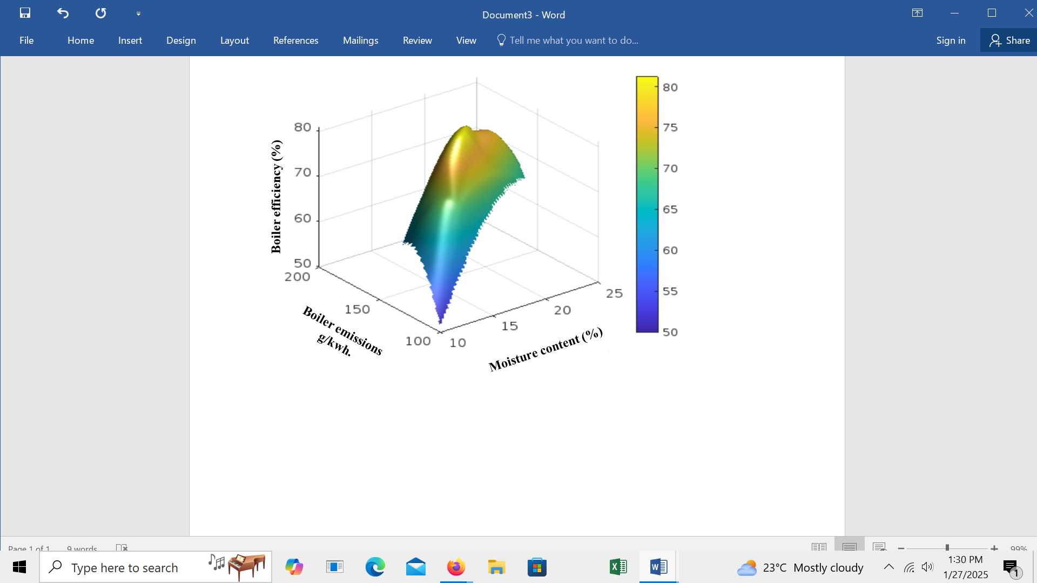

Figure 3.4 surface mesh for efficiency emission and moisture content

The graph indicates that at a moisture content of 18%, the boiler demonstrates a balanced performance with an emissions output of 178 g/kWh and an operational efficiency of 81%.
This moisture level is within the optimal range for combustion, which means the wood fuel is sufficiently dry to combust effectively while retaining enough moisture to avoid harmful combustion processes associated with overly dry fuel. The flue gas emissions value of 178 g/kWh signifies the amount of pollutants released per unit of energy generated. This level of emissions can be viewed as acceptable or suitable, depending on regulatory standards and environmental benchmarks. It indicates a relatively efficient combustion process where the fuel is burned effectively, minimizing waste and energy loss. The 81% efficiency means that 81% of the input energy from the wood fuel is converted into useful energy output, while the remaining 19% is lost through processes such as heat loss in flue gases and unburnt fuel in ash. An efficiency level of 81% is generally considered good for wood-fired boilers, often falling within the range sought for optimized operation. This efficiency indicates that the system is well-tuned to minimize waste and maximize energy extraction from the fuel

4.2 Implications for the Tea Processing Industry
The findings underscore the importance of maintaining optimal moisture content in wood fuel. This optimization approach can lead to significant cost savings while improving the environmental footprint of tea processing operations.

5.0 Conclusion
The study demonstrates that fuzzy logic can effectively optimize moisture content in wood fuel used in boilers for the tea processing industry in Kenya. Future research should focus on integrating real-time data acquisition systems to enhance the adaptability of the fuzzy control system in operational settings.

REFERENCES
- Ahmad, N., Khan, M. A., & Bukhari, A. (2021). Fuzzy logic-based optimization of combustion parameters in biomass boilers. Renewable Energy, 175, 159-167. https://doi.org/10.1016/j.renene.2021.04.012
- Aydin, A., & Koç, I. (2020). Application of fuzzy logic control in industrial processes: A review. Journal of Control Science and Engineering, 2020, Article ID 4891860. https://doi.org/10.1155/2020/4891860
- Gitari, J., & Chege, S. (2019). The impact of moisture content on the combustion efficiency of wood fuel in Kenyan tea factories. International Journal of Environmental Science and Technology, 16(8), 4581-4590. https://doi.org/10.1007/s13762-019-02536-8
- Ogot, N., Kamau, J., & Gitonga, J. (2020). Efficiency challenges in biomass energy systems in tea production in Kenya. Energy Reports, 6, 101-108. https://doi.org/10.1016/j.egyr.2020.10.006
- Zhao, Y., Li, R., & Wang, J. (2022). Real-time adaptive control of biomass combustion with fuzzy logic. Energy Conversion and Management, 249, 114953. https://doi.org/10.1016/j.enconman.2021.114953
- Zadeh, L. A. (1994). Fuzzy logic. IEEE Spectrum, 31(3), 77-83. https://doi.org/10.1109/6.256202
- Karachi, M. N., & Suri, S. (2021). The impact of tea processing on economic growth in rural Kenya. Journal of Economic Perspectives, 35(4), 45-68. https://doi.org/10.1257/jep.20210413
- Kamau, R. W., Ndung’u, M. D., & Gichuki, M. (2023). Enhancing market competitiveness of Kenyan tea through innovative processing techniques. African Journal of Agricultural Research, 18(3), 145-158. https://doi.org/10.5897/AJAR2023.00898
- Mutuku, J., & Karanja, G. (2023). Sustainable practices in tea processing: Challenges and opportunities in Kenya. Sustainability, 15(2), 1051. https://doi.org/10.3390/su15021051
- Ng’ang’a, S. T., Wangari, M., & Ochieng, M. (2022). Advances in tea processing technologies: A review of practices in Kenya. Journal of Food Processing and Preservation, 46(3), e16620. https://doi.org/10.1111/jfpp.16620
- Kumar, A., & Raghav, V. (2023). Impact of feedstock variability on biomass boiler performance: An adaptive control approach. Energy Reports, 9, 1156-1168. https://doi.org/10.1016/j.egyr.2023.01.010
- Lee, J. Y., Park, S. H., & Choi, B. (2023). Machine learning-based optimization for biomass combustion conditions. Journal of Cleaner Production, 395, 136532. https://doi.org/10.1016/j.jclepro.2023.136532

